* Client meeting
  + Randstad
  + Global fortune 500
  + Using salesforce for a year and a half
  + Randstad gets first pick, but there are more companies for sure
  + 3 people from Randstad
    - They all deal with salesforce
    - They will want to expand from what they currently do
    - Head of salesforce practice
    - His boss over all practices
    - Christine
      * Looks at entire workforce management
      * Determines which existing teams we will go to
  + 3 major points
    - Introduction
    - Couple weeks before final project
      * Mock interviews
      * Provide feedback to trainer
    - After final project showcase
      * The big interview
* Lightning app builder
  + Declarative point and click tool for the mobile app and lightning experience
  + 3 types of pages
    - Home page is landing page of an app
    - Record page
    - App page
      * Whatever you want to put on a page
  + All record pages are for one specific object
  + You can drag and drop components
  + Dynamic forms allow for the layout of a page to change based on criteria
    - This is a feature available after you upgrade it
  + Some features are unavailable on mobile so it makes sense to do a desktop and mobile version
  + Salesforce mobile app
    - App that allows access to salesforce on a smartphone
    - Allows the same access as the desktop
    - Can also get mobile reports
    - Action bar/action menu
      * One of which is more if you need more
  + Quick actions
    - Too many mouse clicks for a simple task
    - Can simplify some work for us
    - Can do lots of actions with one button
    - Global and object specific actions are not the same
      * Umbrella term is quick action
    - In the mobile action bar on mobile
    - 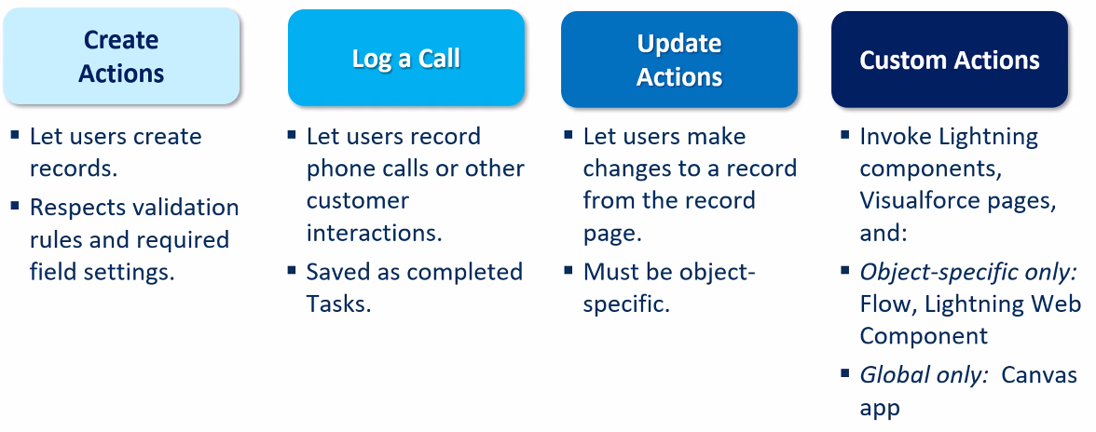
    - They are context aware
      * They can see what you are working on and do things based off of that
    - Global are not context aware
    - Object specific takes into account the object you are working on
    - 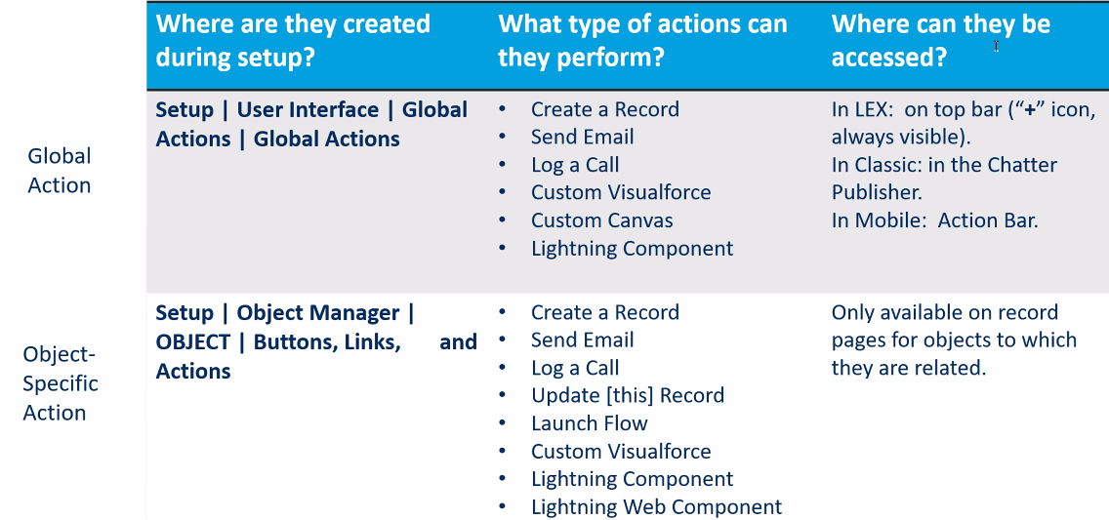
* Review
  + 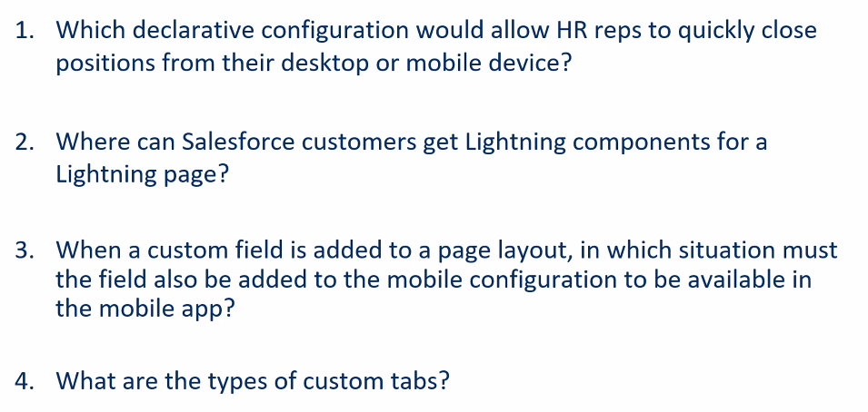
  + Quick actions
  + App exchange
  + Never
    - The only difference is it cannot directly take you to the detail page
  + Lightning component, visual force and record
* Record types
  + Can be used to limit picklist options
  + Used for creating different versions of an object
  + Used in conjunction with page layouts
  + Record types can be set by users
  + Each record type should have its own layout
  + Different types of objects are modeled with record types